**Operations Research -II (IM21006)**

**ASSIGNMENT - III**

**(Submission deadline: 20th February 2022)**

1. Consider the following network, where each number along a link represents the actual distance between the pair of nodes connected by that link. The objective is to find the shortest path from the origin to the destination.

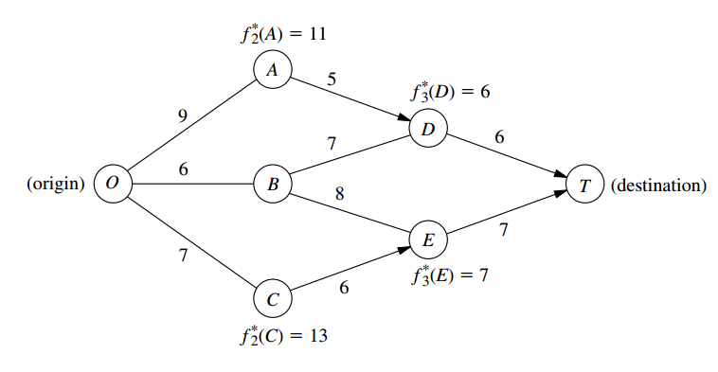

1. What are the stages and states for the dynamic programming formulation of this problem?
2. Use dynamic programming to solve this problem. However, instead of using the usual tables show your work graphically. In particular, start with the given network, where the answers already are given for *f n*\*(*sn*) for four of the nodes; then solve for and fill in *f* 2*(*B*) and *f* 1*(*O*).Draw an arrowhead that shows the optimal link to traverse out of each of the latter two nodes. Finally, identify the optimal path by following the arrows from node *O* onward to node *T*.
3. Use dynamic programming to solve this problem by manually constructing the usual tables for *n* =3, *n* =2, and *n=*1.
4. Use the shortest-path algorithmto solve this problem. Compare and contrast this approach with the one in parts (*b*) and (*c*).
5. The owner of a chain of three grocery stores has purchased five crates of fresh strawberries. The estimated probability distribution of potential sales of the strawberries before spoilage differs among the three stores. Therefore, the owner wants to know how to allocate five crates to the three stores to maximize expected profit. For administrative reasons, the owner does not wish to split crates between stores. However, he is willing to distribute no crates to any of his stores. The following table gives the estimated expected profit at each store when it is allocated various numbers of crates:

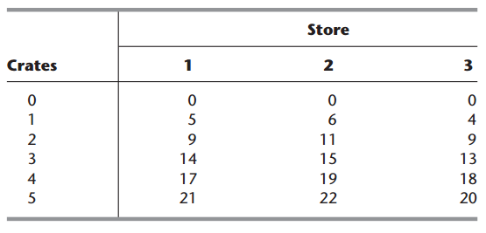

Use dynamic programming to determine how many of the five crates should be assigned to each of the three stores to maximize the total expected profit.

1. A college student has 7 days remaining before final examinations begin in her four courses, and she wants to allocate this study time as effectively as possible. She needs at least 1 day on each course, and she likes to concentrate on just one course each day, so she wants to allocate 1, 2, 3, or 4 days to each course. Having recently taken an OR course, she decides to use dynamic programming to make these allocations to maximize the total grade points to be obtained from the four courses. She estimates that the alternative allocations for each course would yield the number of grade points shown in the following table:

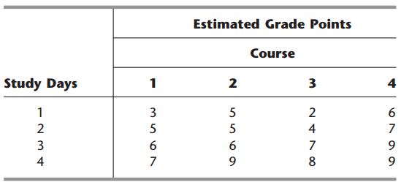

1. Consider the following nonlinear programming problem.



Use dynamic programming to solve this problem.

1. Consider the following nonlinear programming problem



Use dynamic programming to solve this problem.

1. Consider the following “fixed-charge” problem



Use dynamic programming to solve this problem.